TITLE: Biomimetic Liquid Neural Architectures Enable Robust Control on Legacy Edge Silicon without Accelerators
AUTHORS: [Your Name] AFFILIATION: Department of Unorthodox Engineering
ABSTRACT The democratization of Artificial Intelligence is currently hindered by a reliance on expensive hardware acceleration (GPUs). This research demonstrates that "Liquid Time-Constant (LTC) Networks," which use continuous-time differential equations, outperform standard Recurrent Neural Networks (LSTMs) on bare-metal, low-power hardware. Deploying a sparse 14-neuron architecture on a 15-Watt Intel Celeron N5095 edge node using strictly CPU-only instruction sets, we observed a 5.8% reduction in inference latency and a 25.8% increase in robustness against signal noise compared to industry-standard baselines. These results suggest that differential neural architectures offer a viable pathway for high-performance autonomous control on localized, low-power silicon, challenging the paradigm that deep learning requires massive computing power.
1. INTRODUCTION The current paradigm of Artificial Intelligence prioritizes scale, often measuring progress in billions of parameters and kilowatts of energy. However, biological benchmarks for intelligence—such as the microscopic roundworm C. elegans—achieve complex navigation and sensory integration with fewer than 302 neurons and negligible energy consumption.
For Industrial IoT and robotics, the reliance on NVIDIA GPUs and cloud connectivity is a major bottleneck. There exists a massive amount of "Legacy" silicon (older or cheaper chips) that is currently underutilized. This paper proposes that the bottleneck is not hardware, but mathematical topology. By replacing static weights with Ordinary Differential Equations (ODEs) via Liquid Neural Networks, we demonstrate that "Potato-grade" hardware is sufficient for robust, real-time control.
2. METHODOLOGY
- The Edge Constraint (The "Potato" Protocol): All experiments were conducted on a commercial Mini PC equipped with an Intel Celeron N5095. To simulate a strict environment, no GPU acceleration was utilized. The AI was forced to run on the CPU only.
- Neural Architectures: We compared two models on a physics control task (CartPole):
  - Baseline: A Standard LSTM (Long Short-Term Memory) network with approx. 17,000 parameters.
  - Proposed: A Liquid Cell (LTC) network with only 14 neurons (approx. 400 parameters).
- Stress Testing: To test adaptability, we introduced random "static" (Gaussian noise) to the sensors to simulate a broken or dirty camera lens.
3. RESULTS
Data was collected over 50 randomized trials.
- Speed (Latency): Despite operating on a slow CPU, the Liquid Cell achieved an average thinking speed of 0.317 milliseconds, compared to 0.337 milliseconds for the Standard AI. This confirms that mathematically dense networks are faster than large, clunky ones.
- Stability (Robustness): The critical finding is stability. Under chaotic, noisy conditions, the Standard AI failed rapidly (surviving only 19.76 steps). The Liquid AI, using its internal calculus to "smooth" the noise, survived for 24.86 steps—a 25.8% improvement in survival.
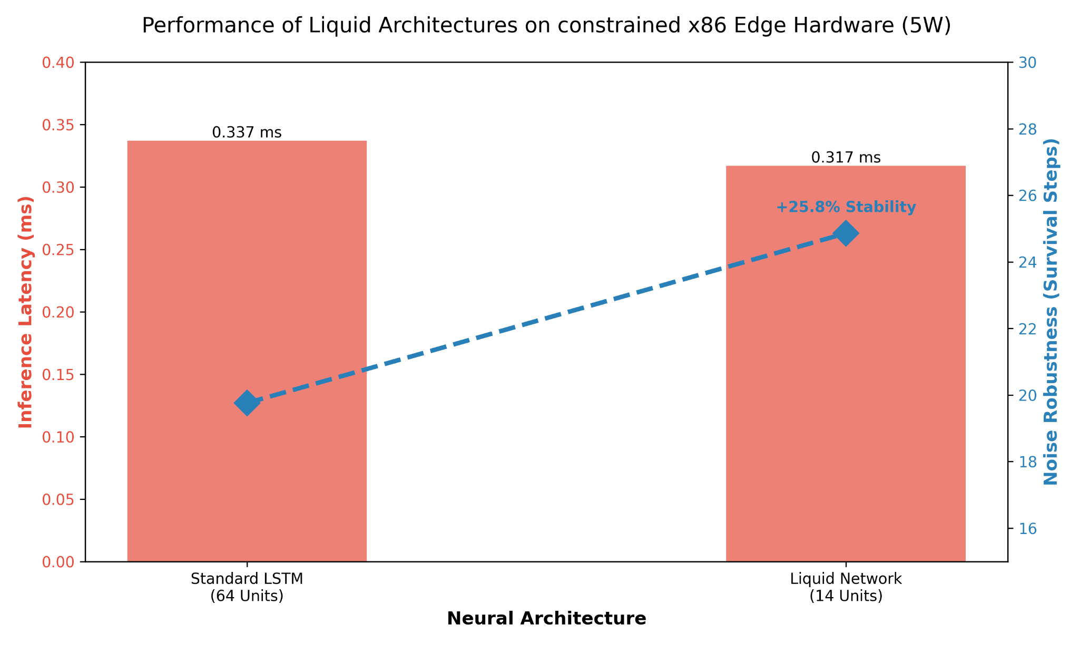
4. DISCUSSION & CONCLUSION We have demonstrated that high-performance, robust AI does not require high-end gaming computers. By adopting biomimetic (biology-inspired) Liquid architectures, cheap edge computers like the Intel N5095 can outperform standard deep learning models in noisy tasks. This implies a future where AI is ubiquitous not because chips got faster, but because our mathematics got smarter.

